#
# Format partition to ext4 and set UUID in the same time.
# Related links.
# https://askubuntu.com/questions/132079/how-do-i-change-uuid-of-a-disk-to-whatever-i-want
# https://unix.stackexchange.com/questions/12858/how-to-change-filesystem-uuid-2-same-uuid
#
[root@m1-gp-prd-bkp1 ~]# mkfs.ext4 -U ea4c635c-9909-449c-bd12-5cdf2d700b78 /dev/sdf1
mke2fs 1.41.12 (17-May-2010)
Filesystem label=
OS type: Linux
Block size=4096 (log=2)
Fragment size=4096 (log=2)
Stride=1 blocks, Stripe width=0 blocks
488382464 inodes, 1953506304 blocks
97675315 blocks (5.00%) reserved for the super user
First data block=0
Maximum filesystem blocks=4294967296
59617 block groups
32768 blocks per group, 32768 fragments per group
8192 inodes per group
Superblock backups stored on blocks:
32768, 98304, 163840, 229376, 294912, 819200, 884736, 1605632, 2654208,
4096000, 7962624, 11239424, 20480000, 23887872, 71663616, 78675968,
102400000, 214990848, 512000000, 550731776, 644972544, 1934917632

Writing inode tables: done
Creating journal (32768 blocks): done
Writing superblocks and filesystem accounting information: done

This filesystem will be automatically checked every 37 mounts or
180 days, whichever comes first. Use tune2fs -c or -i to override.
You have mail in /var/spool/mail/root
[root@m1-gp-prd-bkp1 ~]#

20150710

https://access.redhat.com/labs/fslayoutcalculator/

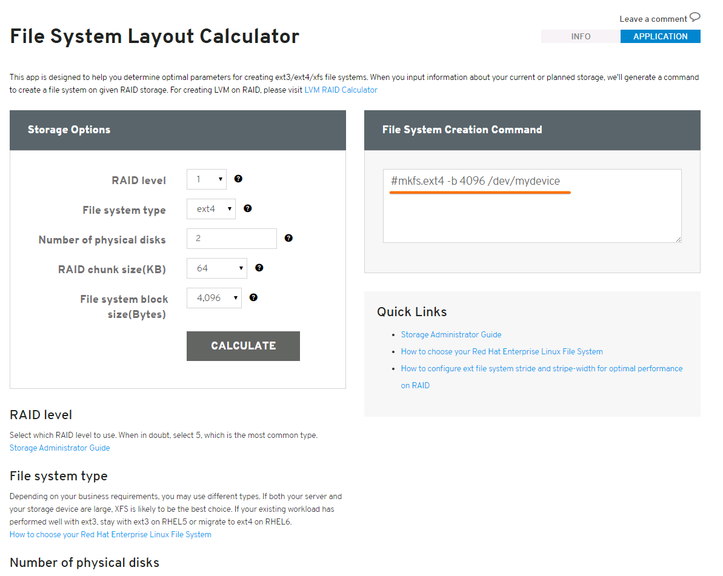

it-212-belogrud ~ # mkfs.ext4 -L data1 /dev/mapper/sdb1-data1
mke2fs 1.42 (29-Nov-2011)
Filesystem label=data1
OS type: Linux
Block size=4096 (log=2)
Fragment size=4096 (log=2)
Stride=0 blocks, Stripe width=0 blocks
30531584 inodes, 122096126 blocks
6104806 blocks (5.00%) reserved for the super user
First data block=0
Maximum filesystem blocks=4294967296
3727 block groups
32768 blocks per group, 32768 fragments per group
8192 inodes per group
Superblock backups stored on blocks:
32768, 98304, 163840, 229376, 294912, 819200, 884736, 1605632, 2654208,
4096000, 7962624, 11239424, 20480000, 23887872, 71663616, 78675968,
102400000
Allocating group tables: done
Writing inode tables: done
Creating journal (32768 blocks): done
Writing superblocks and filesystem accounting information: done

it-212-belogrud ~ #

[root@ds-hadoop-wk04p ~]# mkfs.ext4 -T largefile4 -L worker4_disk1 /dev/sdb1
mke2fs 1.41.12 (17-May-2010)
/dev/sdb1 alignment is offset by 229888 bytes.
This may result in very poor performance, (re)-partitioning suggested.
Filesystem label=worker4_disk1
OS type: Linux
Block size=4096 (log=2)
Fragment size=4096 (log=2)
Stride=64 blocks, Stripe width=64 blocks
476928 inodes, 488369967 blocks
24418498 blocks (5.00%) reserved for the super user
First data block=0
Maximum filesystem blocks=4294967296
14904 block groups
32768 blocks per group, 32768 fragments per group
32 inodes per group
Superblock backups stored on blocks:
32768, 98304, 163840, 229376, 294912, 819200, 884736, 1605632, 2654208,
4096000, 7962624, 11239424, 20480000, 23887872, 71663616, 78675968,
102400000, 214990848

Writing inode tables: done
Creating journal (32768 blocks): done
Writing superblocks and filesystem accounting information: done

This filesystem will be automatically checked every 26 mounts or
180 days, whichever comes first. Use tune2fs -c or -i to override.
[root@ds-hadoop-wk04p ~]#

[root@ds-mon11t ~]# man mkfs.ext4
...
-T usage-type[,...]
Specify how the filesystem is going to be used, so that mke2fs can choose optimal filesystem parameters for that use. The
usage types that are supported are defined in the configuration file /etc/mke2fs.conf(5). The user may specify one or
more usage types using a comma separated list.

If this option is is not specified, mke2fs will pick a single default usage type based on the size of the filesystem to be
created. If the filesystem size is less than or equal to 3 megabytes, mke2fs will use the filesystem type floppy. If the
filesystem size is greater than 3 but less than or equal to 512 megabytes, mke2fs(8) will use the filesystem small. Oth-
erwise, mke2fs(8) will use the default filesystem type default.

[root@ds-mon11t ~]# cat /etc/mke2fs.conf
[defaults]
base_features = sparse_super,filetype,resize_inode,dir_index,ext_attr
blocksize = 4096
inode_size = 256
inode_ratio = 16384

[fs_types]
ext3 = {
features = has_journal
}
ext4 = {
features = has_journal,extent,huge_file,flex_bg,uninit_bg,dir_nlink,extra_isize
inode_size = 256
}
ext4dev = {
features = has_journal,extent,huge_file,flex_bg,uninit_bg,dir_nlink,extra_isize
inode_size = 256
options = test_fs=1
}
small = {
blocksize = 1024
inode_size = 128
inode_ratio = 4096
}
floppy = {
blocksize = 1024
inode_size = 128
inode_ratio = 8192
}
news = {
inode_ratio = 4096
}
largefile = {
inode_ratio = 1048576
blocksize = -1
}
largefile4 = {
inode_ratio = 4194304
blocksize = -1
}
hurd = {
blocksize = 4096
inode_size = 128
}
[root@ds-mon11t ~]#

Here is automatically created filesystem during OS was installed by installation interface.

[root@centos00 scripts]# dumpe2fs -h /dev/sda1
dumpe2fs 1.41.12 (17-May-2010)
Filesystem volume name: <none>
Last mounted on: /boot
Filesystem UUID: cd68fe34-eeb3-406f-8807-864cc907456a
Filesystem magic number: 0xEF53
Filesystem revision #: 1 (dynamic)
Filesystem features: has_journal ext_attr resize_inode dir_index filetype needs_recovery extent flex_bg sparse_super huge_file uninit_bg dir_nlink extra_isize
Filesystem flags: signed_directory_hash
Default mount options: user_xattr acl
Filesystem state: clean
Errors behavior: Continue
Filesystem OS type: Linux
Inode count: 128016
Block count: 512000
Reserved block count: 25600
Free blocks: 457924
Free inodes: 127977
First block: 1
Block size: 1024
Fragment size: 1024
Reserved GDT blocks: 256
Blocks per group: 8192
Fragments per group: 8192
Inodes per group: 2032
Inode blocks per group: 254
Flex block group size: 16
Filesystem created: Wed Aug 28 14:08:01 2013
Last mount time: Wed Jun 25 15:09:25 2014
Last write time: Wed Jun 25 15:09:25 2014
Mount count: 33
Maximum mount count: -1
Last checked: Wed Aug 28 14:08:01 2013
Check interval: 0 (<none>)
Lifetime writes: 56 MB
Reserved blocks uid: 0 (user root)
Reserved blocks gid: 0 (group root)
First inode: 11
Inode size: 128
Journal inode: 8
Default directory hash: half_md4
Directory Hash Seed: 5f4b98ff-a9fa-49af-88ca-d635455a72e7
Journal backup: inode blocks
Journal features: (none)
Journal size: 8M
Journal length: 8192
Journal sequence: 0x00000090
Journal start: 1

